create Procedure Select_Client_Card AS

BEGIN

SELECT [Card_Number]

FROM [Client_Card]

END;

execute Select_Client_Card

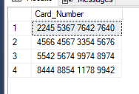

create Procedure Delete_Client_Card

@ID_Client_Card int

AS

begin

Delete from [Client_Card]

Where ID_Client_Card = @ID_Client_Card

End

create Procedure Insert_Client_Card

@Client_ID int,

@Validity varchar(30),

@Card_Holder varchar(30),

@Card_Number varchar(30)

AS

begin

Insert into [Client_Card]

values(@Client_ID,@Validity,@Card_Holder,@Card_Number)

End

DECLARE @1Client_ID int, @1Validity varchar;

DECLARE @1Card_Holder varchar, @1Card_Number varchar

SET @1Client_ID = 1

SET @1Validity = '33/33'

SET @1Card_Holder = 'LLL'

SET @1Card_Number = '1111 1111 1111 1111'

execute Insert_Client_Card @1Card_Number, @1Card_Holder, @1Validity, @1Client_ID

create Procedure Select_Full_Name_Contractor AS

BEGIN

SELECT [Full_Name_Contractor]

FROM [Contractor]

END;

create Procedure Select_Short_Name_Contractor AS

BEGIN

SELECT [Short_Name_Contractor]

FROM [Contractor]

END;

create Procedure Select_Legal_Address_Contractor AS

BEGIN

SELECT [Legal_Address_Contractor]

FROM [Contractor]

END;

create Procedure Select_Physical_Address_Contractor AS

BEGIN

SELECT [Physical_Address_Contractor]

FROM [Contractor]

END;

create Procedure Select_Contractor_E_Mail AS

BEGIN

SELECT [Contractor_E_Mail]

FROM [Contractor]

END;

create Procedure Select_Contractor_Phone_Number AS

BEGIN

SELECT [Contractor_Phone_Number]

FROM [Contractor]

END;

create Procedure Select_ARCoEaO AS

BEGIN

SELECT [ARCoEaO]

FROM [Contractor]

END;

create Procedure Select_BIC AS

BEGIN

SELECT [BIC]

FROM [Contractor]

END;

create Procedure Select_ITN AS

BEGIN

SELECT [ITN]

FROM [Contractor]

END;

create Procedure Select_Price_Service AS

BEGIN

SELECT [Price_Service]

FROM [Service]

END;

create Procedure Select_Service_Name AS

BEGIN

SELECT [Service_Name]

FROM [Service]

END;

create Procedure Select_Compound AS

BEGIN

SELECT [Compound]

FROM [Service]

END;

create Procedure Select_Client_Card_Holder AS

BEGIN

SELECT [Card_Holder]

FROM [Client_Card]

END;

create Procedure Select_Client_Card_Validity AS

BEGIN

SELECT [Validity]

FROM [Client_Card]

END;

execute Select_Client_Card_Validity

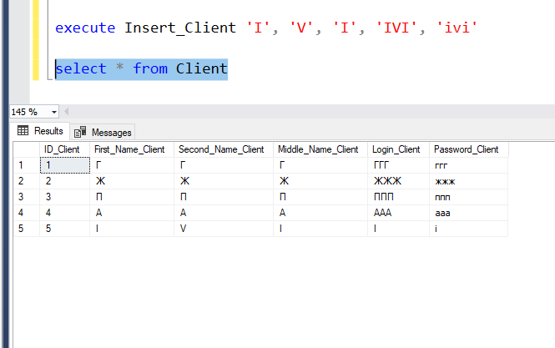

create Procedure Delete_Client

@ID_Client int

AS

begin

Delete from Client

Where ID_Client = @ID_Client

End

execute Delete_Client 5

select * from Client

